Project Description: Using the Moon Alphabet for Point Symbols in Tactile Diagrams

Author: Nicholas Wood, Braille Producer, Royal New Zealand Foundation of the Blind

Contents

Introduction 2
What is a “point symbol”? 4
Limitations on the use of point symbols 4
Requirements of a good point symbol 4
The Moon alphabet 4
Notes on producing the tactile version of the map 6
Sample images of subdivided tactile map 7
Appendix: The Moon Alphabet 9
Reference Sheet 10

Introduction
In July 2014 our Accessible Format Production department produced a tactile Unified English Braille (UEB) version of the “Hamilton (New Zealand) Central Business District (CBD) Accessible Map” for Hamilton City Council, using Adobe Illustrator software and swell (microcapsule) paper.
The project was funded by “Think Differently”, a Ministry of Social Development fund promoting changing attitudes: http://thinkdifferently.org.nz/braille-maps. They funded the original print version of the map and then the braille and large print.
The disability community assisted with the first version of the print map and the blind and low vision community gave a lot of feedback around what they wanted included, excluded and what the map could look like. For some it was the first time they had ever seen a tactile map.
There were approximately two dozen different point symbols in the original print map (see following print map).
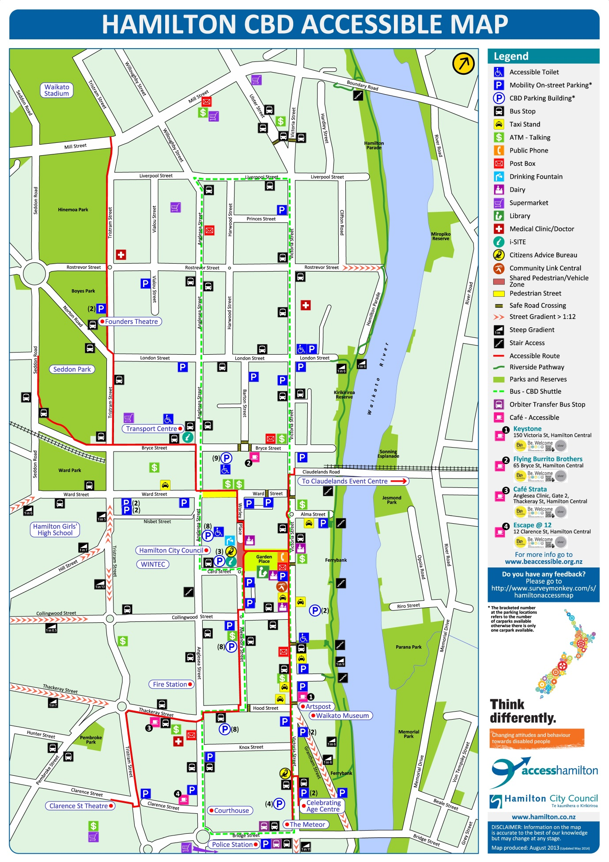

What is a “point symbol”?
“Guidelines and Standards for Tactile Graphics, 2010” (GSTG) published by the Braille Authority of North America (BANA) defines a point symbol as “3.1.3 A point symbol indicates a specific place within the graphic. It is usually placed in an area or on a line and represents specific data, such as a city, a bus stop, an oil well, a point in a line graph, or a gland in an anatomy diagram.”
In Appendix I—Glossary of Terms, “GSTG” defines a point symbol as, “A dot, circle, square, rectangle or other small symbolic item assigned to represent the specific location of an object or feature.”

Limitations on the use of point symbols
It goes on to say, “3.2.2 In general, a single graphic should contain no more than five different area textures, five different line styles, and five different types of point symbols. If more are needed to represent the information required, consider using an alphabetic key.”
And, “7.3.11 When there are more than five area textures or five line textures or five point symbols, the diagram may have to be separated into sections. (See Unit 3, Planning and Editing, 3.9.)” Use of the Moon alphabet should help overcome the need to separate the diagram into sections, so reducing production time.
A map of the mineral resources of Southwest Asia in the “GSTG” says of the multiple point symbols in that map, “(7.6) The point symbols shown here are deliberately designed as distinctive graphic symbols rather than braille keys. This was done in order to stay true to the purpose of this special-purpose map, in which the distribution of the `symbols` shows where the various economic activities occur.”

Requirements of a good point symbol
“GSTG” states, “3.4.3.11 Point Symbols. For discrimination between two or more different-shaped symbols, the minimum diameter must be at least 1/4 inch (6 millimeters).”
Also, “11.4.1 Strong lines, clear and uncomplicated textures, and simple point symbols should be used to represent the information in diagrams for young readers.”
I believe the Moon alphabet is ideal for providing simple point symbols for all readers.

The Moon alphabet
We used the RNIB Moon font at a 24-point size in our map (please see Moon alphabet in Appendix). It was downloaded from: http://www.moonliteracy.org.uk/font.htm
William Moon (1818-1894) published his own system of raised type in 1845. According to the Moon literacy organisation, “Moon is larger and the characters are more `open` than braille, so easier to feel and decipher. Moon requires a considerably less acute sense of touch than braille, so can sometimes help readers with diabetes whose finger sensitivity is reduced.” (http://www.moonliteracy.org.uk/whatis.htm) This simplicity of recognising the Moon alphabet led me to believe that its letters would be a good alternative to using shapes such as “dots, circles, squares” etc. for point symbols.
Because the Moon alphabet has 26 distinct shapes (one for each letter), there is no need for a tactile map to be limited to just five different types of point symbols, as recommended in “GSTG” (3.2.2). The need to resort to a two-cell braille alphabetic key would be reduced, saving valuable space on the map. For example the letter “a” in Moon at 24-point size is this symbol:
A
This is less than the space taken up by two braille cells at the same standard 24-point size:
==
In our Hamilton map, I was able to represent almost all the point symbols (icons) used in the original print map, owing to the distinctiveness of the Moon letters. The Moon letters chosen for the key were as follows. Although the Moon letters were listed in alphabetical order in the key for each division of the map, the Moon letters were only used as distinctive shapes. No attempt was made to relate the literal alphabetical meaning of each Moon letter to the name of the object it represented:
A Bus Stop
b Mobility On-street Parking
c ATM—Talking
d Taxi Stand
e Stair Access
f Accessible Toilet
g Supermarket
j Medical Clinic/Doctor
k Citizens Advice Bureau
l i-Site
m Orbiter Transfer Bus Stop
n Community Link Central (WINZ)
o Drinking Fountain
p Library
q Blind Foundation Office
u To Claudelands Event Centre

Notes on producing the tactile version of the map
- The map was enlarged for tactile use by dividing it into six subdivisions. It was divided once vertically and twice horizontally, as can be seen by the dashed lines in the overview map on braille page 3, and shown below:
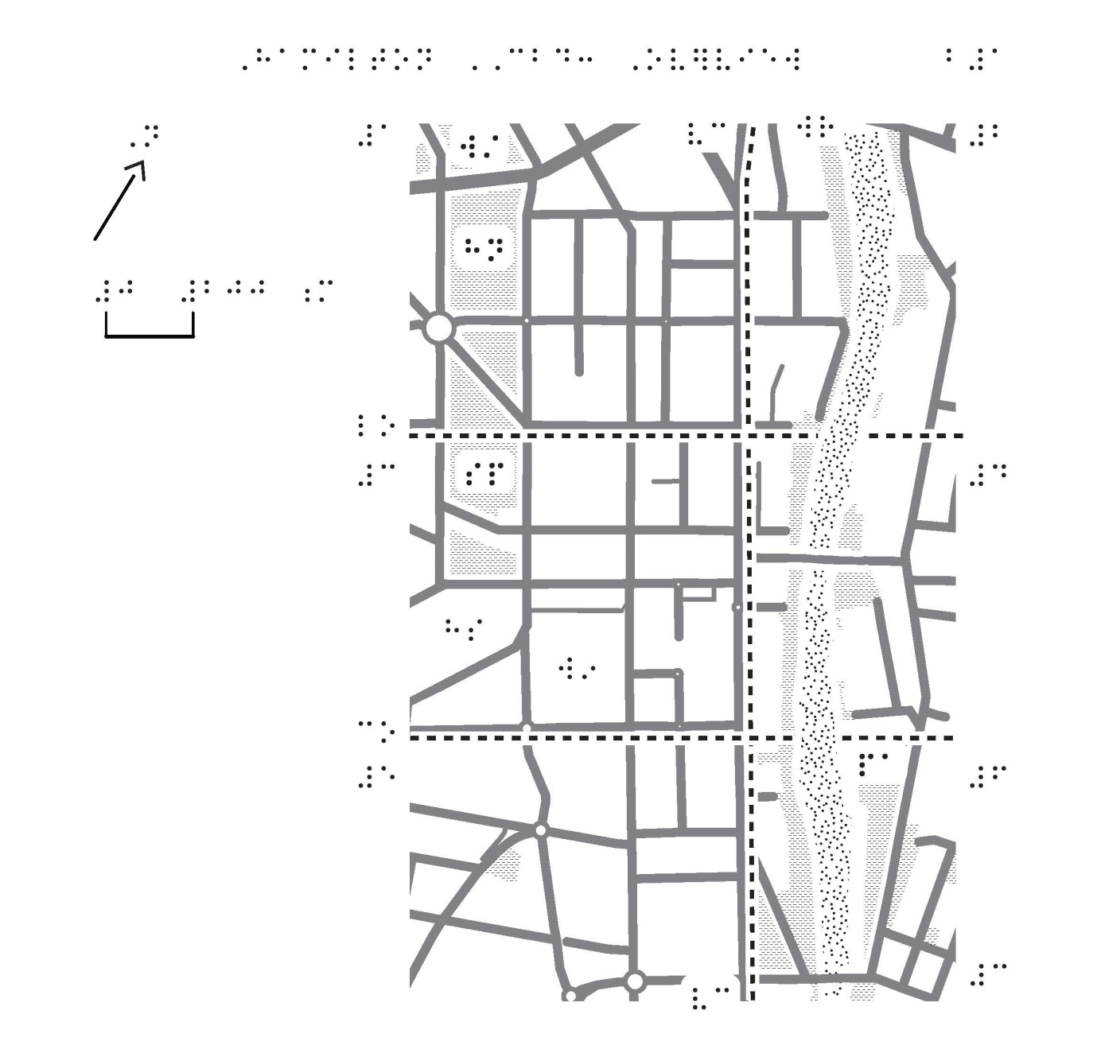
- The running head is not consistent throughout the volume. It was modified for various sections of the volume in order to provide more vertical space for the maps.
- The key for each map subdivision was split so that textures and point symbols are on a facing page, and the alphabetical list of street and place names forms the fold-out section of the opposite joined page, together with the map itself.
- Contrary to usual braille formatting practice, a Contents preliminary page and an Index not existing in print were created in braille, to assist in making the braille version more useful to the reader.
- It should be noted that it is important to “outline” the RNIB Moon font in the Adobe Illustrator file, so that the shapes of the Moon letters are faithfully preserved when viewing or printing the map on a computer which does not have the Moon font installed on it.

Sample images of subdivided tactile map
Division 3: Key appearing on facing braille page f8:
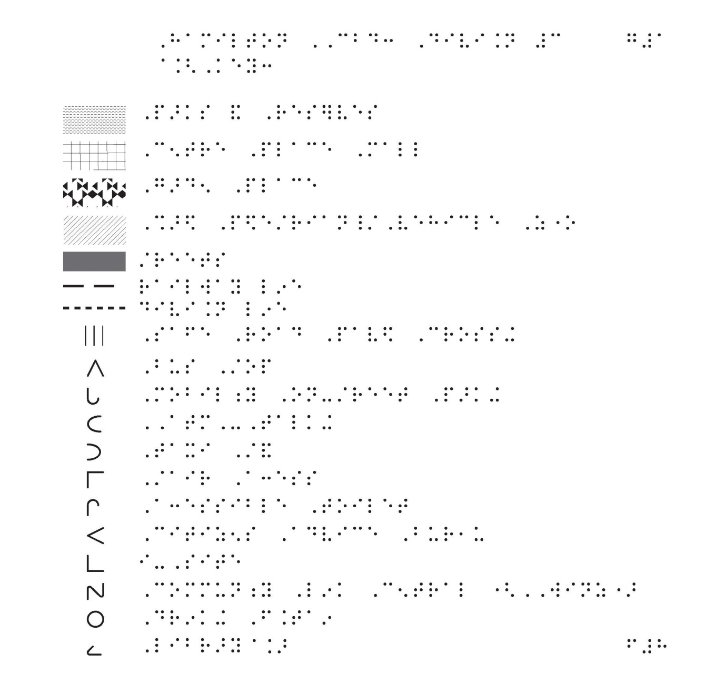
Division 3: subdivision of map appearing on joined braille page j9:
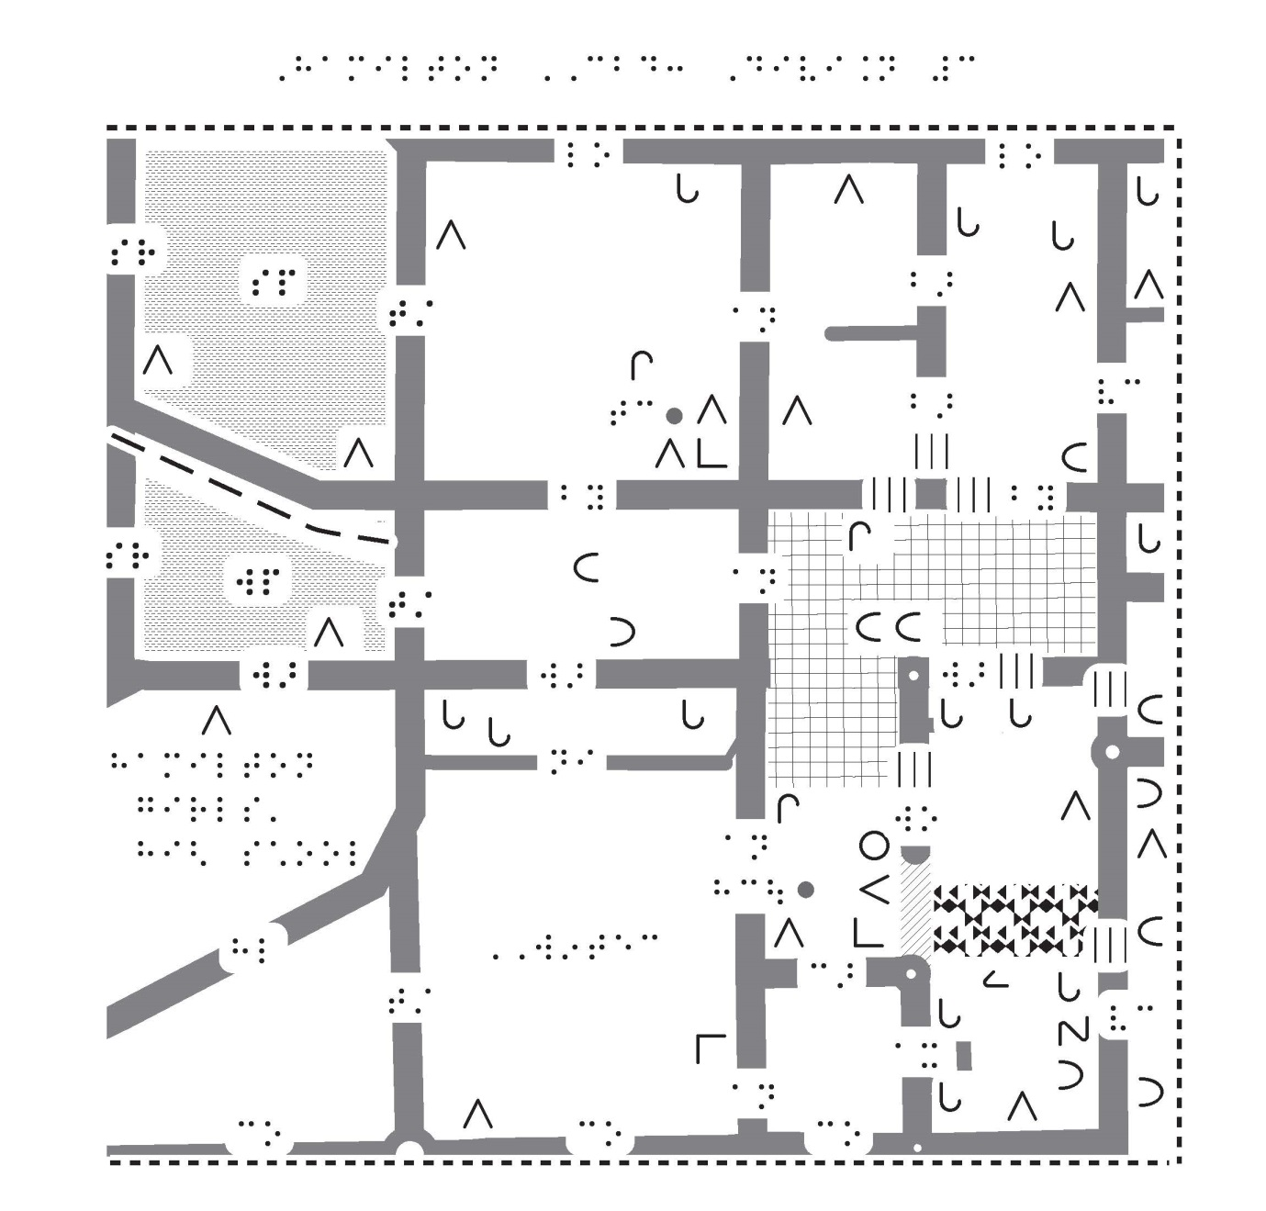

Appendix: The Moon Alphabet
A a t t
b b u u
c c v v
d d w w
e e x x
f f y y
g g z z
h h
i i
j j
k k
l l
m m
n n
o o
p p
q q
r r
s s

Reference Sheet
The project was funded by “Think Differently”, a Ministry of Social Development fund: http://thinkdifferently.org.nz/braille-maps

The print version of the Hamilton CBD Accessible Map is available at http://www.hamilton.govt.nz/our-city/community-development/advisoryservices/Documents/Hamilton%20CBD%20Accessible%20Map%20PDF%20Version.pdf

“Guidelines and Standards for Tactile Graphics, 2010” (GSTG) published by the Braille Authority of North America (BANA) is available from http://www.brailleauthority.org/tg/

The Moon font is available for download from http://www.moonliteracy.org.uk/font.htm

