Super Animals Sound Cards Project
  - Author: Maria Stevens

Contents

Introduction 2
Background 2
Gathering the Tools 3
Key Objectives 5
Production 5
Album and Card Reader 6
Conclusion 6
Acknowledgements 7
References 8

Introduction
At the beginning of May 2015 the supermarket chain Countdown launched a promotion advertised on television as The Super Animal Sound Cards. In the advertisement you saw a variety of animals running, jumping and frolicking in the grass. There were animal noises being played at the same time and then a voice over advising what this promotion was all about. It was not clear to people with a vision impairment what exactly you needed to do in order to gain the benefit from this promotion.

Background
Countdown stores are located throughout New Zealand and they offer a one stop household shopping experience. They have facilities that enable you to do your shopping online and get it delivered to your home, which many of my friends find most convenient.

The Blind and Low vision Education Network New Zealand, BLENNZ, based in Manurewa, South Auckland, as one of its services houses a National Youth Library where children, parents of children with a vision impairment and Resource Teachers Vision RTV’s can borrow Accessible format books in Braille, Collage, Twin Vision, Large print and audio.

Accessible Format Services based at the Blind Foundation in Auckland is responsible for producing mainly educational material for students in braille, tactile graphics, e-text, large print and audio.

I am a life-long braille reader and have limited vision which enables me to move between the braille and print world although my preferred format is braille. I have two grown up children, one with a vision impairment. I am also blessed with two grandchildren who are fully sighted. When I heard about this promotion from Countdown I thought this would be something my grandchildren would enjoy so I set out to collect the 108 cards, purchase the album and the card reader. Little did I know that I would get just as much out of the whole experience as they both did. This set me to thinking of vision impaired children who may enjoy the interaction as much as I did and this is how this project came about.
Part of my role at the Blind Foundation is to manage braille producers, braille proof-readers, volunteer copyholders and volunteer collage producers.
I first inquired through the Youth librarian and one or two RTV’s if this would be a project worth doing and be of interest to the students. Because many of our vision impaired children are in mainstream settings they are very aware of what is in at the moment with their sighted peers. So this was timely and topical and felt to be worthwhile.

Gathering the Tools
When you spend $20, and for every $20 you spend at your Countdown store, whether it be on-line shopping or going in to the store and shopping, you are given a piece of thick card. This card can be torn open and divided into four small cards with one shiny side and one rough side. So when you open the card there are four pictures and some facts about the animal on each card. The cards are all jumbled up so you could get a 1, 39, 43 or 100 in one thick card. On the rough side there is a barcode running down the length of one side and an advertisement about the Animal Sound Cards. The cards have a number on each one and these are colour coded for example, light blue cards start at 1 and finish at 12. Lime green cards start at 13 and finish at 24. The last set of cards is coloured light pink, starts at 97 and finishes at 108.

The album is a hard covered, 29.8 cm wide and 29.8 cm long, 2 cm high three-hole punch folder. The front cover is coloured bright blue. In the centre of the cover there is an illustration of a large, roughly textured sparkly-grey globe of the world. In the centre of the globe are bright yellow words, “Super Animals”. The words are interspersed with pictures of animals; tiger, blue parrot, giraffe, penguin, monkey, frog, zebra, dolphin, snake, whale and a butterfly. All the animals and birds have exceptionally large eyes. Several music symbols are floating on the top portion of the globe. The letter “S” on the word “Animals” is in the shape of long animal tail. A small brown monkey is hanging onto this tail and chattering, “There’s a sound in every card!” The logos for Countdown and SPCA [Society for the Prevention of Cruelty to Animals] New Zealand are written at the bottom of the front and back covers.

The back cover of the album is also bright blue. In the centre of the cover there is a small group of animals: a seal standing on a rock, an elephant balancing a sparkly grey globe of the world on which an armadillo is standing; a hippopotamus with an owl on its back and a sprinkling of music symbols. Below the animals are the words, “Activity and Collector’s Album.”

At the bottom left-hand side of the cover there is a small green insect standing on a sign which reads: “WARNING! Not suitable for children under 3 years, Contains small parts.” On the right-hand side of the cover there is a pink piggy bank. A parrot is fluttering above the piggybank and is about to deposit a gold coin. The parrot squawks, “$1 from every album sold is donated to the SPCA.”

The inside front cover shows a brightly coloured jungle scene. There are trees of many shapes and heights. In a grassy clearing there are several animals and birds. A parrot is holding a sign in its claws which reads, “Stick your photo here!” In the clearing there is an antelope who informs us that, “Kiwis love their animals. They own around 1.4 million cats, 700,000 dogs and 1.6 million fish! Did you know there are around 245 bird species in New Zealand?”

Superimposed over the illustration is the following:

THIS BOOK BELONGS TO
Name: -
Species: -
Age: -
Height: -
Favourite animal: -
Favourite country: -

$1 from every Super Animals Activity and Collector’s Album sold is donated to the SPCA to help advance the welfare of all animals in NZ. Thank you for your support!

The inside back cover is headed, “108 Super animals to collect” and shows another jungle scene with birds, insects, and various animals. Superimposed over the illustrations are thumbnail sized photographs of all the cards in the collection, shown in their specific groups, ie: The fastest, the toughest; the deadliest, the smartest, the fiercest, the weirdest, the sneakiest, the loudest, the showiest.

A large black crow holding a pencil in its beak is reminding us to “Keep track of your collection by ticking off the Super Animals Sound Cards you own!”
A bright blue parrot exclaims, “Wow, so many cards!”

Set in a purple box is the following: “Doubled up? Missing a Super Animals Sound Card? Do a swap with your friends, or visit countdown.co.nz/superanimals to swap your cards and complete your collection.”

Inside the folder there are 12 full page size plastic see-through sleeves and each of the large page size sleeves are divided into 12 small pockets to insert the cards. Between each large sleeve there is one glossy, coloured print page with activities, puzzles and lots of information. Due to the large amount of print material in this album we had to be selective about what text we were able to include in the braille.

The card reader is roughly the size of a cigarette packet, with a small round speaker in the middle on one side, a flexible handle attached to the reader on one corner and a slot to slide the barcode side of the card into.

I sent emails out to teachers, friends, work colleagues and parents asking if they had spare sound cards could I please have them as I planned to produce four sets for our National Youth library. When we produce collage titles we produce four copies for our National Youth library so that was where the number to produce originated.

Some of my friends with a vision impairment had received these cards with their household grocery shopping but were unsure how to use them so when my email arrived they were more than happy to give me their cards.

However once news spread about this project I was inundated with the sound cards and requests from RTV’s who wanted to have an album in their local Resource Centre. At the end of this project we had produced 20 copies of the albums, complete with 108 cards in each album and card reader attached.

Key Objectives
One of the key objectives for producing this unusual, yet timely resource was to demonstrate that collaboration with the requester and a large food chain can result in a great outcome for students and adult braille readers who have a vision impairment.
Another key objective is to highlight the importance for our students who are braille readers to be involved with timely activities along with their sighted peers. This enhances the social experience for both blind and sighted children in mainstream settings.

Production
The first step in this process was to sort out the large amount of cards that were received from everyone. Help was needed as the 108 cards did not come in order so sorting them by colour, then consecutive numbering, was quite a big task which was done mainly by volunteers.
Then making sure complete sets were completed and inserting them in to their appropriate spaces in the hard covered albums took place. Whilst this sorting was taking place decisions needed to be made about:
- What information was of most importance to be brailled
- Where to place the braille number on each card
- How to label the plastic sleeves for ease of reference
- As there were activities and recipes, should these be brailled, and if so how could we fit them in to the album
- What would the album feel and look like once completed
- How would the card reader be attached to the album
- Would the National Youth Library need spare cards in case some were lost or bent
- How many braille pages would fit into the small binder but would not squash the braille
- And other queries that arose once production began.
Once the first album was complete with all 108 cards the brailling, cutting, labelling collating and checking processes began. When you look at a print copy of the album you think “Oh well producing this in braille should be easily achievable.” However it was a much more in-depth, trial and error process which took a large amount of time and effort but feedback has been positive.
The card reader comes in four colours blue, green, red and yellow, the size of a cigarette packet one side with a small round speaker, a strap on the top right-hand corner and a small slot on one of the long sides for a card to be inserted and the sound to be heard.
Some queries around the card reader:
- How to attach the card reader to the album so the two pieces would be kept together when used by the students
- How easy was it to change the tiny battery in each of these card readers
- How durable were these readers
- Where could card readers be sourced if replacements were needed

The production process took at least three months once braille production started as it had to be prioritised around other braille requests.

Album and Card Reader
A card is selected from the album, the card reader is held in one hand, you locate the slit, slide the card barcode side at the top of the slit down slowly and you should hear an animal sound for that particular animal, or something akin to it. Many of the sounds are quite unusual. The many facts noted are interesting and the small colour pictures are well done for those who can see just a little.

Conclusion
I have got 4 copies here to show you the culmination of work and effort which has gone into this project. I hope you enjoy them as much as the children who this album was created for.

Acknowledgements
SPCA [Society for the Prevention of Cruelty to Animals] New Zealand

The Blind Foundation

ICEB The International Council on English Braille

Countdown
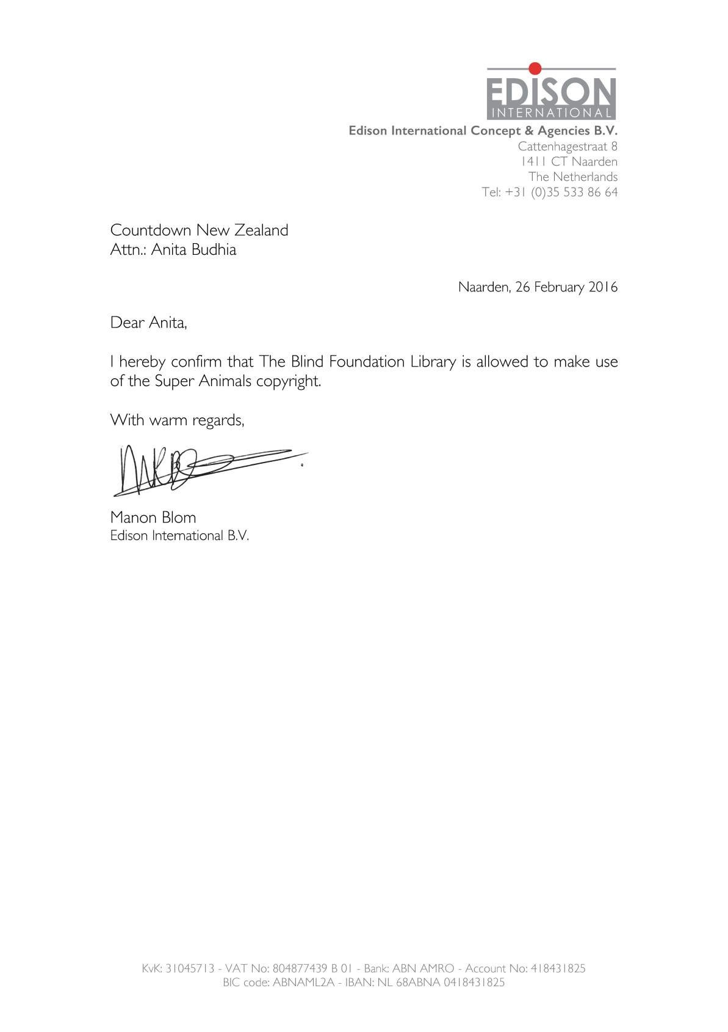

References
BANA Guidelines and Standards for Tactile Graphics, 2010

UEB Australian Training Manual revised April 2014

The Rules of Unified English Braille Second Edition 2013 ICEB

UEB Braille Manual New Zealand Edition August 2013

